**ISO 20022**

Target2-Securities - Collateral

Approved by the Securities and Payments SEG under the leadership of the Securities SEG on the 19th of July 2019.

**Message Definition Report** **- Part 1**

Edition July 2019

Table of contents

1. Introduction 3

1.1 Terms and definitions 3

1.2 Glossary 3

1.3 Document Scope and Objectives 4

1.4 References 4

2. Scope and Functionality 5

2.1 Background 5

2.2 Scope 5

2.3 Groups of Message Definitions and Functionality 6

3. BusinessRoles and Participants 7

4. BusinessProcess Description 10

4.1 BusinessProcess Diagram 10

4.2 Business process flow 12

5. Description of BusinessActivities 13

5.1 Description of activities – Query Management Process 14

6. Business Transactions 16

7. Revision Record 18

**Preliminary note:**

The Message Definition Report (MDR) is made of three parts:

* **MDR - Part 1** describes the contextual background required to understand the functionality of the proposed message set. Part 1 is produced by the submitting organisation that developed or maintained the message set in line with a MDR Part1 template provided by the ISO 20022 Registration Authority (RA) on [www.iso20022.org](http://www.iso20022.org)
* **MDR – Part 2** is the detailed description of each message definition of the message set. Part 2 is produced by the RA using the model developed by the submitting organisation.
* **MDR – Part 3** is an extract of the ISO 20022 Business Model describing the business concepts used in the message set. Part 3 is an Excel document produced by the RA.

# Introduction

## Terms and definitions

The following terms are reserved words defined in ISO 20022 – Part1. When used in this document, they will follow the UpperCamelCase notation.

|  |  |
| --- | --- |
| Term | Definition |
| BusinessRole | functional role played by a business actor in a particular BusinessProcess or BusinessTransaction |
| Participant | involvement of a BusinessRole in a BusinessTransaction |
| BusinessProcess | unrealized definition of the business activities undertaken by BusinessRoles within a BusinessArea whereby each BusinessProcess fulfils one type of business activity and whereby a BusinessProcess may include and extend other BusinessProcesses |
| BusinessTransaction | particular solution that meets the communication requirements and the interaction requirements of a particular BusinessProcess and BusinessArea |
| MessageDefinition | formal description of the structure of a MessageInstance |

## Glossary

**Acronyms/Abbreviations**

|  |  |
| --- | --- |
| Acronym | Definition |
| 4CB | Banca d’Italia, Banque de France, Deutsche Bundesbank and Banco d’España |
| ACH | Automated Clearing House |
| A2A | Application-to-Application mode. Defines a mode of technical communication that permits the exchange of information between software applications of T2S and a directly connected T2S actor. |
| BAH/head.001 | Business Application Header |
| Head.002 | Business File Header for multi messages |
| BIC | Business Identifier Code |
| CeBM | Central Bank Money |
| CSD | Central Securities Depository |
| ID | Identification |
| MDR | Message Definition Report |
| NCB | National Central Bank |
| RTGS | Real-time gross settlement (RTGS) system.  A settlement system in which processing and settlement take place in real-time on a gross basis. |
| SEG | Standards Evaluation Group |
| T2S | TARGET2-Securities |
| TM | Technical Message. Messages which cover technical functions within T2S System |
| U2A | User-to-Application mode. Defines a mode of technical communication that permits the exchange of information between software applications of T2S and a T2S system user through a graphical user interface (GUI). |
| URD | T2S User Requirement Document |
| XML | eXtensible Mark-up language |

## Document Scope and Objectives

This document is the first part of the ISO 20022 Message Definition Report (MDR) that describes the BusinessTransactions and underlying message set. For the sake of completeness, the document may also describe BusinessActivities that are not in the scope of the project.

This document sets:

* The BusinessProcess scope (business processes addressed or impacted by the project)
* The BusinessRoles involved in these BusinessProcesses

The main objectives of this document are:

* To explain what BusinessProcesses and BusinessActivities these MessageDefinitions have addressed
* To give a high level description of BusinessProcesses and the associated BusinessRoles
* To document the BusinessTransactions and their Participants (sequence diagrams)
* To list the MessageDefinitions

## References

| Document | Version | Date | Author |
| --- | --- | --- | --- |
| ISO 20022 Business Justification – Securities settlement and reconciliation http://www.iso20022.org/documents/BJ/BJ042/ISO20022BJ_T2S_v2_with_comments.pdf | 2.0 |  | 4CB |
| T2S User Requirements (URD)  https://www.ecb.europa.eu/paym/t2s/pdf/2016-08-01_urd_v5_05.pdf | 5.05 | 08.2016 | ECB |

# Scope and Functionality

## Background

This Message Definition Report covers a set of two Collateral Message Definitions developed by Deutsche Bundesbank on behalf of 4CB in close collaboration with SWIFT and approved by the Securities and Payments SEG under the leadership of the Securities SEG on the 19th of July 2019.

Originally, these messages have been designed to support the T2S community for Collateral management. T2S (TARGET2-Securities) is a European securities settlement engine which offers centralised settlement in central bank money across all European securities markets. The fundamental objective of T2S is to integrate and harmonise the highly fragmented securities settlement infrastructure in Europe. It aims to reduce the costs of cross-border securities settlement and increase competition and choice among providers of post-trading services in Europe.

To support information about collateral values, the Query Management module of T2S supports three different query types, providing a drill-down of the current collateral value of securities on stock per T2S dedicated cash account and securities account.

The detailed description of each Message Definition is provided in Message Definition Report Part 2.

## Scope

These two Message Definitions (colr.001 and colr.002) support three different query types and are specifically designed to provide information on the current collateral value of securities on stock per cash account and securities account. The response to a query always contains the timestamp specifying the system time when the data selection was actually performed. The response messages to value queries will deliver information on all securities and cash balances that meet the specifications defined in the query. In addition, the information on securities balances are complemented with their balance types and the system time at which the balance snapshot was taken.

## Groups of Message Definitions and Functionality

This Collateral message set consists of the CollateralValueQuery (colr.001) and the CollateralValueReport (colr.002). Both messages will be used with the ISO 20022 Business Application Header (head.001).

Please find below high level information about the functionality of the messages:

The CollateralValueQuery (colr.001) message is sent by a System Member to the Central System (e.g. T2S). It aims at querying the current available value of securities for auto collateralisation. In response to the CollateralValueQuery, the Central System sends a CollateralValueReport (colr.002) containing information on requested items or business error report.

These Collateral query messages are foreseen to support the following message usages:

* The Total collateral value per Cash Account Query/Response allows the system user to query the total current collateral value of securities that is earmarked and available (on stock) for auto-collateralisation for a cash account.
* The Collateral value per Cash Account Query/Response allows the system user to receive information on the collateral value of securities on stock per Cash Account and per security.
* The Collateral value of a security Query/Response allows the system user to query for a specific security the current collateral value of the security, earmarked and available (on stock) for auto-collateralisation, in every securities account linked to a specific cash account.

# BusinessRoles and Participants

A BusinessRole represents an entity (or a class of entities) of the real world, physical or legal, a person, a group of persons, a corporation. Examples of BusinessRoles: “Financial Institution”, “ACH”, “CSD”.

A Participant is a functional role performed by a BusinessRole in a particular BusinessProcess or BusinessTransaction: for example the “user” of a system, “debtor”, “creditor”, “investor” etc.

The relationship between BusinessRoles and Participants is many-to-many. One BusinessRole (that is, a person) can be involved as different Participants at different moments in time or at the same time: "user", "debtor”, "creditor", "investor", etc. Different BusinessRoles can be involved as the same Participant.

A business actor represents an entity (or a class of entities) of the real world, physical or legal, a person, a group of persons, a corporation. E.g. of business actors: “Financial Institution”, “ACH”, “CSD”, NCB.

A business role is a role performed by a business actor in a specific business context and process: e.g. the “user” of a system, “debtor”, “creditor”, “investor” etc.

Relationship between business roles and actors is many-to-many. One business actor (i.e. a person) can play different roles at different moments in time or at the same time: "user", "debtor, "creditor", "investor" etc. One role can also be played by different actors.

Hierarchy of Roles in T2S as a securities settlement engine:



T2S supports a hierarchical model of roles and access rights to ensure the segregation of both functions and data. The area of the slide shaded in grey represents the data set-up for T2S dedicated cash accounts required in the static data of T2S. An NCB, acting as a CSD in its home country and providing dedicated cash accounts in T2S, will have the role of NCB and CSD and will exist in T2S as both a CSD and an NCB.

In the context of Liquidity Management, the high-level business roles and typical actors can be represented as follows.

| Actors an Roles definitions | |  |
| --- | --- | --- |
| Description | Mapping to actors/roles within Cash management | Definition |
| Instructing Party | System Member | Party that instructs the executing/servicing party to process and monitor a transaction. |
| Executing/Servicing Party | System Member | Party that process, monitor and report on transactions received from an instructing party. |
| Settlement Infrastructure Direct Participant | System Member | The party which is not a CSD and that is directly connected to the Settlement Infrastructure Platform. It could be a local custodian, a global custodian, a stock exchange, a central counterparty… |
| Settlement Infrastructure | System Transaction Administrator | The party that provides services to its members for the settlement of transactions and holding of assets (e. g. T2S, RTGS). |
| T2S operator | System Member | The T2S operator is the top level of the hierarchical role and access rights model. The T2S operator role classification includes all T2S system users of the entity, which will be responsible for the day-to-day operation and management of T2S. The T2S actors managed by this entity shall be CSDs and NCBs participating in T2S. At the highest level, the T2S operator shall have access to all data and functionality in the subordinate level. |
| Business role NCB | System Member | The NCB role classification shall include all T2S system users of a NCB as a liquidity provider through T2S dedicated cash accounts. |
| Business role payment bank | System Member | The payment bank role includes all T2S system users of payment banks that require access to the T2S dedicated cash account balances and postings of the T2S dedicated cash accounts they provide for the purpose of securities settlement. |
| System Transaction Administrator | actors/roles within Cash management | In a central system, the entity or neutral body, in charge of providing services to the system's members. It is in charge of performing specified tasks on behalf and under the responsibility of the system's direct members. It can be a matching engine, a settlement engine, or a financial institution. It also maintains accounts or netting balances for the direct members of the system, registers transactions, performs checks and validations, and manages the settlement cycle or other value added processes, as specified in the functional specifications of the system. |
| System Member | actors/roles within Cash management | The party that is entitled to make full or partial use of the system transaction administrator, to make it perform business processes on its behalf. A member can submit transactions, and request and/or receive information. A member can be a direct or indirect member. |

|  |  |  |
| --- | --- | --- |
| **Business Actors/Roles Matrix Table** | | |
| Roles  Actors | System Member | System Transaction Administrator |
| T2S operator | x |  |
| NCB | x |  |
| Payment Bank | x |  |
| Settlement Infrastructure |  | X |
| Settlement Infrastructure Direct Participant | x |  |

# BusinessProcess Description

## BusinessProcess Diagram

The following diagram gives an overview of different types of queries used within Central System:

Settlement Instruction Queries:

Central System shall allow Central System Actors to perform queries on settlement instructions based on the actor’s roles and privileges. For example, for System Actors all instructions that have been sent by either the System Actor or by other Central System Actors that have been authorised by the System Actor to do so;

Securities Account Position Queries:

System users of CSD Participants, CSDs as well as payment banks and NCBs are allowed to send Securities Account Position and Securities Account Position History Queries.

Cash Related Queries:

Central System shall provide NCBs, settlement banks and payment banks, in accordance with their access rights, with the possibility to query e. g. the current balance of one or more Central System dedicated cash accounts.

Dynamic Data Queries:

The only query in this section is the “Report Query”, which provides a System user with the possibility to query the latest available report.

Static Data Queries:

Central System shall provide static data queries to all directly connected System actors. A System Actor shall be able to perform only those queries for which the actor has the necessary privileges. The queries shall return only those data for which the System actor has the necessary access right.

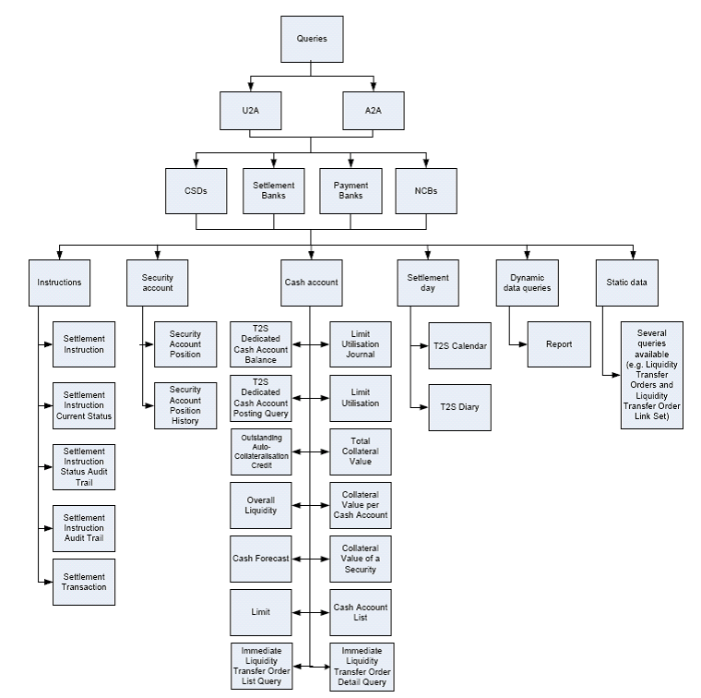

## Business process flow



# Description of BusinessActivities

This section presents the different BusinessActivities within each BusinessProcess. BusinessActivities of a process are described in swim lane diagrams and are referred in this document as activity diagrams.

The development of an activity diagram is part of the ISO 20022 modelling process and allows capturing the requirements.

The activity diagram provides a zoom-in on the BusinessActivities taking place during each of the BusinessProcesses described in the following sections. It also shows the BusinessActivities that are triggered when another BusinessActivity has a negative result.

What is the activity diagram about?

* It is a diagram representing the ‘common lifecycle’ of a BusinessProcess
* A start point ⚫ shows where the lifecycle of the BusinessProcess commences and the end points show End point where the lifecycle may possibly end
* A lozenge means that a choice between several actions can be made
* A bar means that several actions are initiated in parallel
* The flow of activities between the involved Participants (parties)
* BusinessActivities may result in different actions, that is, information is conveyed from one party to another party.

Both in-scope and out-of-scope activities are included, with a different level of details. There are no information requirements for out-of-scope activities, except that they should be clearly identified in the diagram.

Activity diagrams are always accompanied with a text describing the BusinessActivities and their interactions.

## Description of activities – Query Management Process

Notes: In the frame of Central System flow, instructing party corresponds to the direct participant, payment bank or CSD, the servicing/executing party or the receiving party is the settlement infrastructure who achieves the report query request.



|  |  |
| --- | --- |
| **Description of the Business Activities** | |
| **System Member** | **System Transaction Administrator** |
| **CollateralValueQuery:**  Request for Information concerning collateral values on a specific account | **Rejection message:** Informs the instruction party (by error and description) in case if the instruction of CollateralValueQuery was not valid for processing.  There could be three different reasons for a rejection message:  - plausibility check not successful  - permission check not successful  - extracting process not successful |
|  | **CollateralValueResponse:** Delivers the requested data, if available, to the infrastructure of the requesting system member |

# Business Transactions

This section describes the message flows based on the activity diagrams documented above. It shows the typical exchanges of information in the context of a Business Transaction.



As outlined above, an NCB, CSD or directly connected Central System party sends a Collateral Value Query to the Central System (e.g. T2S platform) to request information on the current available value of securities for auto collateralisation. The value will represent the amount of intraday credit that a party may receive through collateralising of their securities. Error Response or Collateral Value Response are both exclusive.

An overview of the communication flow and sequence diagram can be found below:



# Revision Record

|  |  |  |  |  |
| --- | --- | --- | --- | --- |
| **Revision** | **Date** | **Author** | **Description** | **Sections affected** |
| 0.1 | 15.03..2019 | Beiermann/Bräuer (BBk, 4CB) | First draft based on the already available HLBR’s | all |
| 0.2 | 30.04.2019 | ISO 20022 RA | Revision before distribution to the SEGs | all |
| 1.0 | 29.07.2019 | ISO 20022 RA | Approved version | all |
|  |  |  |  |  |

**Disclaimer**:

Although the Registration Authority has used all reasonable efforts to ensure accuracy of the contents of the iso20022.org website and the information published thereon, the Registration Authority assumes no liability whatsoever for any inadvertent errors or omissions that may appear thereon. Moreover, the information is provided on an "as is" basis. The Registration Authority disclaims all warranties and conditions, either express or implied, including but not limited to implied warranties of merchantability, title, non-infringement and fitness for a particular purpose.

The Registration Authority shall not be liable for any direct, indirect, special or consequential damages arising out of the use of the information published on the iso20022.org website, even if the Registration Authority has been advised of the possibility of such damages.

**Intellectual Property Rights**:

The ISO 20022 MessageDefinitions described in this document were contributed by Deutsche Bundesbank on behalf of 4CB and SWIFT for Target2-Securites. The ISO 20022 IPR policy is available at www.ISO20022.org > About ISO 20022 > Intellectual Property Rights.